Heptagrammic Rotunda
# Source: AI Source: Provided by: [Data Path: Persons Table -> ID Column: 1, Name_En Column: Motasem Essam] -> From: [ChatGPT] on [7/25/2026]
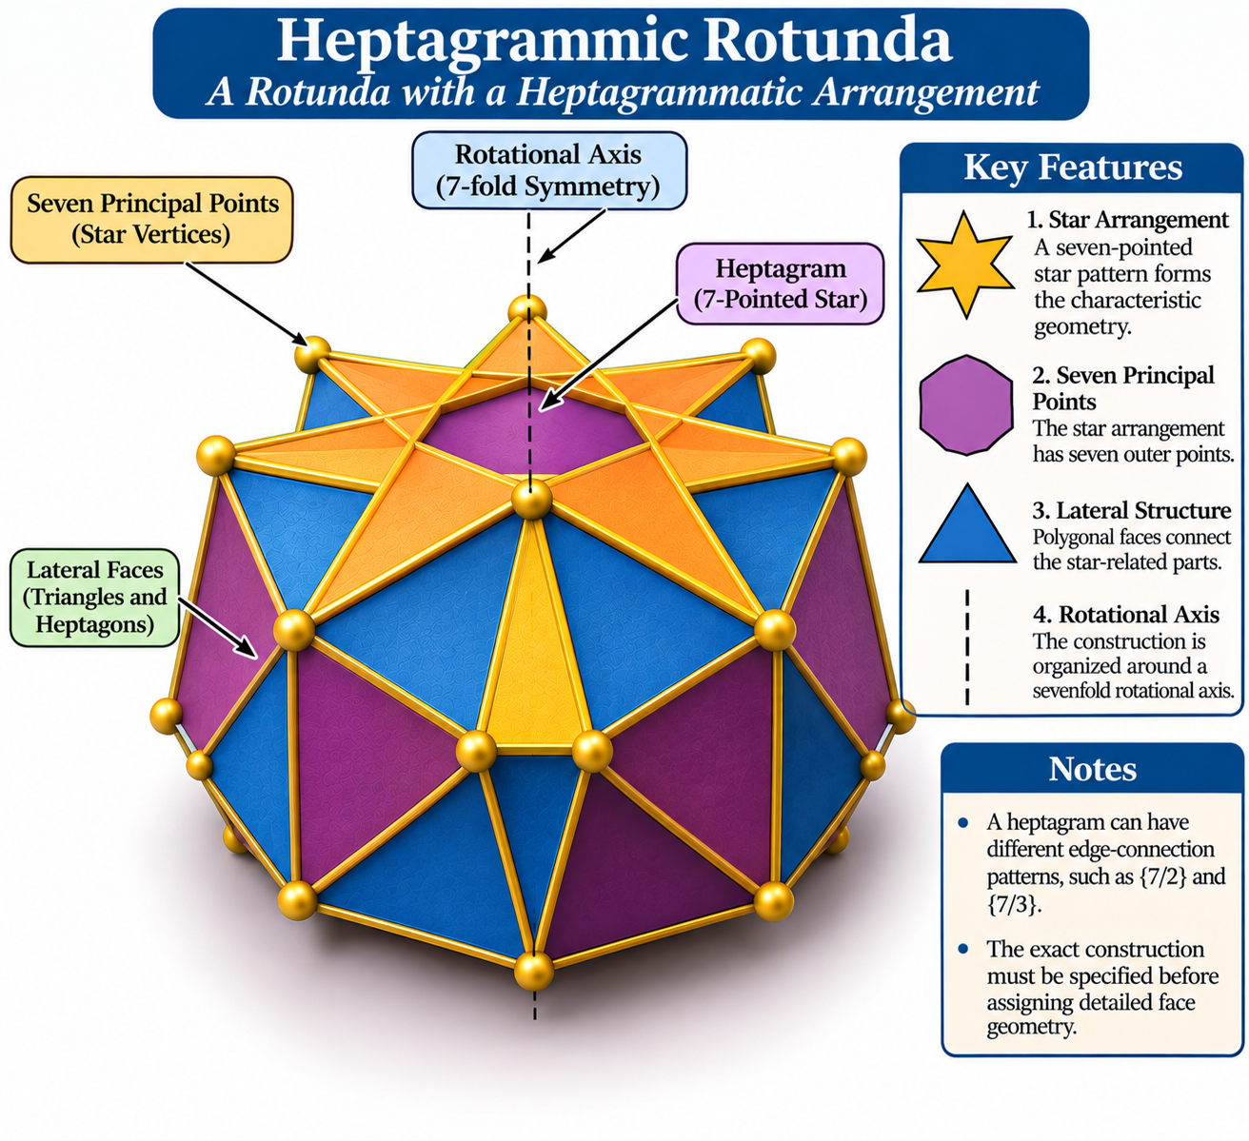

Definition
# Source: AI Source: Provided by: [Data Path: Persons Table -> ID Column: 1, Name_En Column: Motasem Essam] -> From: [ChatGPT] on [7/25/2026]
A Heptagrammic Rotunda is a named member of the Star-Rotunda family, characterized by a heptagrammatic arrangement (a seven-pointed star).
It is classified alongside the Pentagrammic, Enneagrammic, and Hendecagrammic Rotundas. <Cite refs={["turn223677search12","turn223677search1"]}/>
The term heptagrammic refers to a seven-pointed star arrangement, rather than an ordinary convex heptagon.

Geometric Structure
# Source: AI Source: Provided by: [Data Path: Persons Table -> ID Column: 1, Name_En Column: Motasem Essam] -> From: [ChatGPT] on [7/25/2026]
Its defining geometric feature is the heptagrammatic arrangement:
- Star Arrangement: A seven-pointed star pattern forms the characteristic geometry.
- Seven Principal Points: The star arrangement has seven principal outer points.
- Lateral Structure: Polygonal faces connect the star-related parts of the solid.
- Rotational Axis: The construction is organized around an axis associated with sevenfold rotational symmetry.
A heptagram can have different edge-connection patterns, such as $\{7/2\}$ and $\{7/3\}$. The exact construction must therefore be specified before assigning detailed face geometry. <Cite refs={["turn223677search16","turn223677search13"]}/>

Geometric Characteristics
# Source: AI Source: Provided by: [Data Path: Persons Table -> ID Column: 1, Name_En Column: Motasem Essam] -> From: [ChatGPT] on [7/25/2026]
- Solid Type: Star-rotunda-type polyhedron.
- Defining Polygonal Arrangement: Heptagram.
- Principal Points: 7.
- Rotational Pattern: Sevenfold arrangement.
- Geometric Nature: Star-shaped construction.
- Convexity: May be non-convex or self-intersecting, depending on the model.
- Face Composition: Depends on the particular construction.
- Mathematical Counts: No verified universal face, edge, or vertex counts are established.

Construction of Heptagrammic Rotunda

Geometric Instruments Used
# Source: AI Source: Provided by: [Data Path: Persons Table -> ID Column: 1, Name_En Column: Motasem Essam] -> From: [ChatGPT] on [7/25/2026]
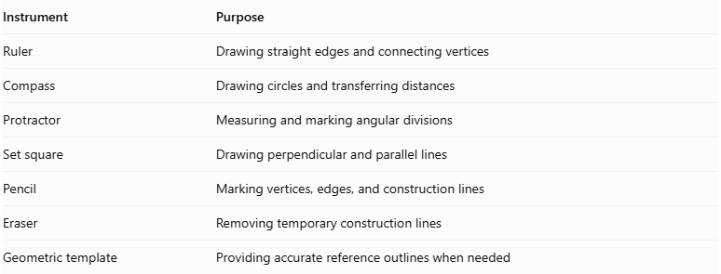
Instrument | Purpose
Ruler | Drawing straight edges and connecting vertices
Compass | Drawing circles and transferring distances
Protractor | Measuring and marking angular divisions
Set square | Drawing perpendicular and parallel lines
Pencil | Marking vertices, edges, and construction lines
Eraser | Removing temporary construction lines
Geometric template | Providing accurate reference outlines when needed

Instrument-Based Construction Procedures

Constructing the Regular Heptagonal Reference
# Source: AI Source: Provided by: [Data Path: Persons Table -> ID Column: 1, Name_En Column: Motasem Essam] -> From: [ChatGPT] on [7/25/2026]
- Draw a circle using a compass.
- Mark its center $O$.
- Divide the circumference into seven approximately equal angular sections using a protractor.
- Mark the seven points $A,B,C,D,E,F,G$ in circular order.
- Check that the points are equally spaced around the circle.
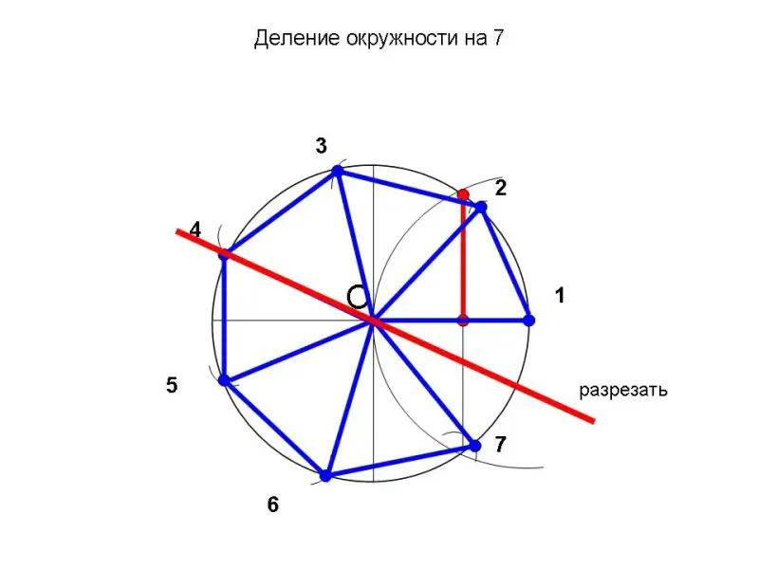
Angular measurement:
$$θ=\frac{{360}^{°}}{7}≈{51.4286}^{°}$$
Construction limitation: A regular heptagon cannot be constructed exactly using only a compass and an unmarked straightedge. A protractor or a prepared geometric template can be used for a measured or approximate construction.

Constructing the Heptagram
# Source: AI Source: Provided by: [Data Path: Persons Table -> ID Column: 1, Name_En Column: Motasem Essam] -> From: [ChatGPT] on [7/25/2026]
For the $\{7/2\}$ heptagram:
- Start at vertex $A$.
- Connect $A$ to $C$.
- Connect $C$ to $E$.
- Connect $E$ to $G$.
- Connect $G$ to $B$.
- Connect $B$ to $D$.
- Connect $D$ to $F$.
- Connect $F$ back to $A$.
This creates a continuous seven-pointed star.
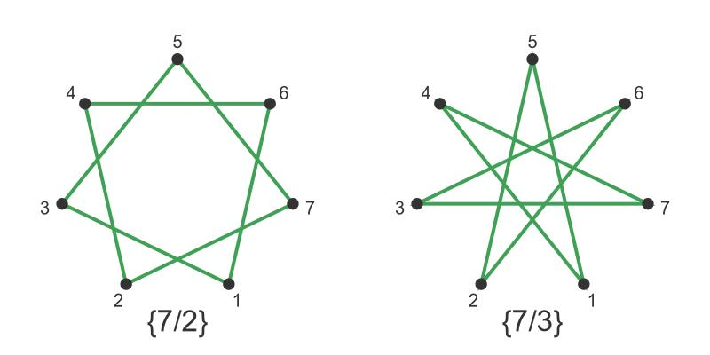
For the alternative $\{7/3\}$ great heptagram, use the following connections:
$$A→D→G→C→F→B→E→A$$
Star-polygon angular step:
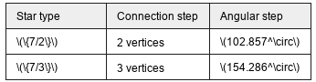
Star type | Connection step | Angular step
$$\{7/2\}$$ | 2 vertices | $${102.857}^{°}$$
$$\{7/3\}$$ | 3 vertices | $${154.286}^{°}$$
Both are valid regular heptagrams. Use the same star type as the chosen three-dimensional reference model.

Constructing the Parallel Arrangement
# Source: AI Source: Provided by: [Data Path: Persons Table -> ID Column: 1, Name_En Column: Motasem Essam] -> From: [ChatGPT] on [7/25/2026]
- Draw a second construction plane parallel to the first.
- Mark its center.
- Reproduce the seven-point reference arrangement.
- Maintain the intended orientation and relative alignment between the two arrangements.
- Check the spacing and positioning of the corresponding vertices.

Establishing the Central Axis
# Source: AI Source: Provided by: [Data Path: Persons Table -> ID Column: 1, Name_En Column: Motasem Essam] -> From: [ChatGPT] on [7/25/2026]
- Identify the center of the upper arrangement.
- Identify the center of the lower arrangement.
- Draw a perpendicular line passing through both centers.
- Extend the line to represent the central axis.
- Use this axis as the reference for the solid's rotational arrangement.

Connecting the Upper and Lower Arrangements
# Source: AI Source: Provided by: [Data Path: Persons Table -> ID Column: 1, Name_En Column: Motasem Essam] -> From: [ChatGPT] on [7/25/2026]
- Identify the corresponding vertices in both arrangements.
- Connect the vertices according to the selected Heptagrammic Rotunda reference model.
- Draw the required lateral edges using a ruler.
- Establish the boundaries of the lateral faces.
- Check that the connections reproduce the reference model without adding arbitrary edges.

Completing the Solid Representation
# Source: AI Source: Provided by: [Data Path: Persons Table -> ID Column: 1, Name_En Column: Motasem Essam] -> From: [ChatGPT] on [7/25/2026]
- Complete the upper and lower star-shaped boundaries.
- Complete the lateral face outlines.
- Draw visible edges using continuous lines.
- Draw hidden edges using dashed lines.
- Erase unnecessary construction lines.
- Label the star arrangements, lateral faces, vertices, and central axis.
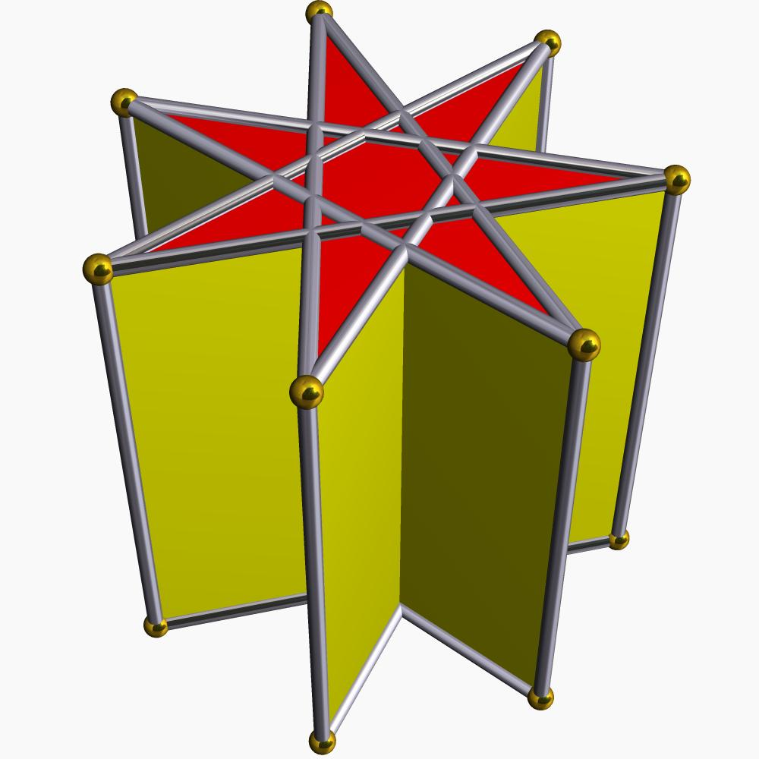

Key Points
# Source: AI Source: Provided by: [Data Path: Persons Table -> ID Column: 1, Name_En Column: Motasem Essam] -> From: [ChatGPT] on [7/25/2026]
- The Heptagrammic Rotunda belongs to the Star-Rotunda family.
- Its defining arrangement is based on a seven-pointed star.
- It is distinct from the ordinary Heptagonal Rotunda.
- Different heptagram forms can produce different geometric arrangements.
- Its exact mathematical properties require a specified three-dimensional construction.

Main Classification
# Source: AI Source: Provided by: [Data Path: Persons Table -> ID Column: 1, Name_En Column: Motasem Essam] -> From: [ChatGPT] on [7/25/2026]
Solid Geometry
└── Types of Solids
└── Star-Rotundas
└── Types of Star-Rotundas
└── Heptagrammic Rotunda
└── Heptagrammic Arrangement

Conclusion
# Source: AI Source: Provided by: [Data Path: Persons Table -> ID Column: 1, Name_En Column: Motasem Essam] -> From: [ChatGPT] on [7/25/2026]
The Heptagrammic Rotunda is a specialized Star-Rotunda characterized by a seven-pointed star arrangement. Its detailed face composition and mathematical properties should be determined from a verified geometric model rather than assumed from the ordinary rotunda formulas.
Classification distinction: A Heptagrammic Rotunda is not the same as a Heptagonal Rotunda. The former uses star-polygon geometry, while the latter uses an ordinary heptagonal base.

